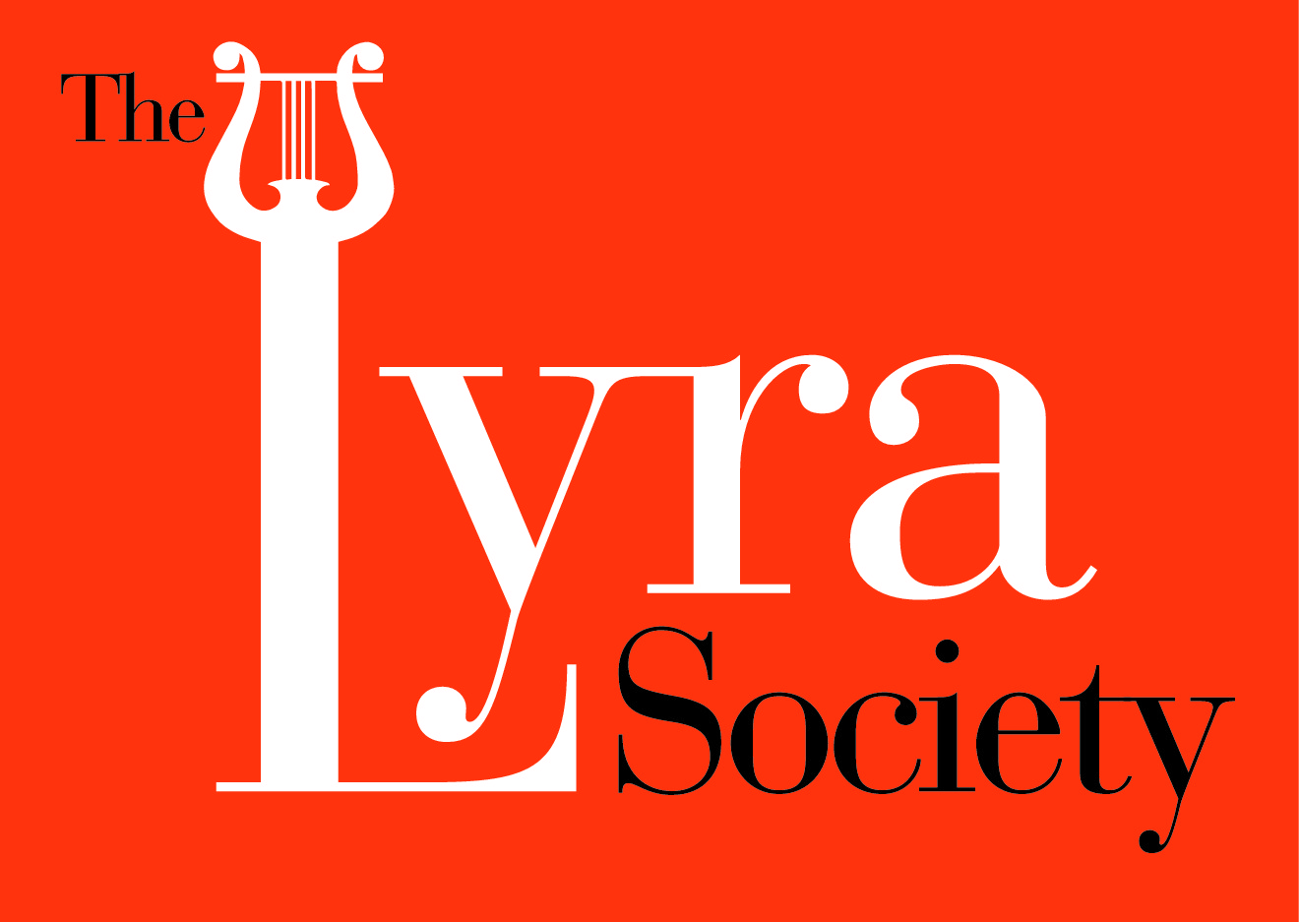  
The Lyra Society Announces the

6th Annual Costello Competition for Composition

The Lyra Society, established in 2004, was created to increase awareness of the harp as a

major solo instrument, expand the harp repertoire by commissioning gifted composers, educate young harpists, and enrich the lives of students. To select the recipient of the sixth annual Costello Commission, the Lyra Society is hosting a two-stage composition competition. The winner will receive a **$1,000.00 cash prize** along with a **world premiere** in the Curtis Field Concert Hall at the Lyra Society’s annual benefit concert, and **publication by Fatrock Ink Music Publishers.** All students currently enrolled in University studies are eligible to participate. This competition is currently open to US and Canadian citizens.

JUDGES:

* Dr. David Ludwig – Artistic Advisor and Chair of Composition, Curtis Institute of Music.
* Elizabeth Hainen – Principal Harp, The Philadelphia Orchestra and Director of the Lyra Society.
* Michael Djupstrom – Composer, Pianist and previous Costello Commission winner.

FIRST STAGE:

Interested composers please submit the following:

* Samples (with accompanying audio files and PDFs of the score) of no more than two 3-5 minute excerpts from two solo or chamber works. At least one excerpt with an example of harp writing is strongly encouraged.

* Deadline for submission is **October 1st, 2018**

SECOND STAGE:

**For the 2018-2019 competition three finalists will each write a solo piece for harp that is 8-10 minutes in length.** Composers are encouraged to work with a harpist from their school in order to field some of the difficult questions of writing for harp.* Competition Co-Director Elizabeth White Clark will review each piece directly with the composer before its final submission.

Deadline for submission will be **February 1st, 2019**. Winner will be announced by **February 15th, 2019.** The goal of this competition is to encourage the creation of new music featuring harp that is well suited for the instrument. The prize will be awarded at the premiere recital, which will be held in April/May 2019 in Curtis Field Concert Hall at the annual Lyra Society benefit concert.

*Composers are highly encouraged to work with a harpist from their school throughout their composition process. Writing for the harp presents many unique challenges. Utilizing a harpist produces pieces better suited for the instrument that can be played time and time again instead of the all too often scenario of a premiere being the one and only performance. In past years, those who have followed this process have had greater success. Competition Director Elizabeth White Clark will also review the piece before the final submission.

First Stage Submission Information

**Please include the following in the submission:**

1. Cover letter stating name, contact information, school attending, and excerpt titles. The contact information provided will be used to announce the winners. As the competition is anonymous submission, this information must be complete to identify your submission after judging. You will receive a confirmation email once your submission has been received. If you do not get this email, please re-submit.
2. Audio files (mp3) and PDF scores of no more than two, (one preferably with harp) 3-5 minute excerpts of your work. These works should be limited to chamber and solo instrumentation. Submissions should have all identifying information, aside from title, removed to ensure anonymity. Failure to do so will result in disqualification.

**Where and how to submit:**

<https://www.dropbox.com/request/PbCm7oxl8PIfjtQDEUxz>

You will receive an email confirmation from Elizabeth Clark that your submission has been received and is complete. If you do not receive a confirmation, please submit again and email elizabeth.white.clark@gmail.com.